**Assignment No: 04**



**Fall 2021**

**CSE-305 Engineering Economics**

Submitted by: **Ashfaq Ahmad**

Registration No: **19PWCSE1795**

Class Section: **B**

“On my honor, as student of University of Engineering and Technology, I have neither given nor received unauthorized assistance on this academic work.”

Student Signature: ______________

Submitted to:

**Dr: Ma’am Durre Nayab**

**March** 5, 2022

**Department of Computer Systems Engineering**

**University of Engineering and Technology, Peshawar**

**Task:** **Design a computer program (Software) for the following basic interest time flow formulas using object-oriented programming.**

1. Single Payment Series.
2. Random / Uneven Payment Series
3. Uniform Payment Series
4. Gradient Payment Series

**Source Code:**

#include <iostream>

#include <cmath>

using namespace std;

class calculator

{

public:

void single_payment(float i,int n);

void uneven_payment(float i,int n);

void uniform_payment(float i,int n);

void Gradient_payment(float i,int n);

};

void calculator::single_payment(float i,int n)

{

float condition,PW=0,FW=0;

cout<<"\n1.FW given PW\n";

cout<<"2.PW given FW\n";

cout<<"\nPlease! select the menu: ";

cin>>condition;

if(condition==1) //present worth

{

cout<<"Please! Enter PW: ";

cin>>PW;

FW=PW*pow(1+i,n);

cout<<"The Future Worth FW is: "<<FW<<endl;

}

else if(condition==2)

{

cout<<"Please! Enter FW: ";

cin>>FW;

float a=pow(1+i,n);

float b=1/a;

PW=FW*b;

cout<<"The present Worth PW is: "<<PW<<endl;

}

else

cout<<"sorry! invalid input";

}

void calculator::uneven_payment(float i,int n)

{

float condition,PW=0,FW=0;

float payment[n];

cout<<"Please! Enter the amount of uneven payments.\n";

cout<<"the year in which no payment occur please enter 0 there.\n";

for(int b=1; b<=n; b++)

{

cout<<"Year "<<b<<": ";

cin>>payment[b];

}

cout<<"\n1.PW given uneven payment\n";

cout<<"2.FW given uneven payment\n";

cout<<"\nPlease! Select menu: ";

cin>>condition;

if(condition==1)

{

for(int b=1; b<=n; b++)

{

float a=0,d=0,c=0;

a=pow(1+i,b);

d=1/a;

c=payment[b]*d;

PW=PW+c;

}

cout<<"The present worth of given Uneven payment is: "<<PW<<endl;

}

else if(condition==2)

{

int x=n-1,b;

for(b=1; b<=n; b++)

{

float a=0,c=0;

a=pow(1+i,x);

c=payment[b]*a;

FW=FW+c;

x--;

}

cout<<"The Future worth of given Uneven payment is: "<<FW<<endl;

}

else

cout<<"Sorry! Invalid input";

}

void calculator::uniform_payment(float i,int n)

{

float condition,PW=0,FW=0,AW=0;

cout<<"1. FW given AW\n";

cout<<"2. PW given AW\n";

cout<<"3. AW given PW\n";

cout<<"4. AW given FW\n";

cout<<"\nPlease! select the menu: ";

cin>>condition;

if(condition==1)

{

cout<<"please! Enter AW: ";

cin>>AW;

float a=pow(1+i,n);

float b=(a-1)/i;

FW=AW*b;

cout<<"The Future Worth given Annuity: "<<FW<<endl;

}

else if(condition==2)

{

cout<<"please! Enter AW: ";

cin>>AW;

float a=pow(1+i,n);

float b=i*a;

float c=(a-1)/b;

PW=AW*c;

cout<<"The Present Worth given Annuity: "<<PW<<endl;

}

else if(condition==3)

{

cout<<"Please! Enter Present Worth: ";

cin>>PW;

float a=pow(1+i,n);

float b=i*a;

float c=b/(a-1);

AW=PW*c;

cout<<"The Annuity given present worth is: "<<AW<<endl;

}

else if(condition==4)

{

cout<<"Please! Enter Future Worth: ";

cin>>FW;

float a=pow(1+i,n);

float b=i/(a-1);

AW=FW*b;

cout<<"The Annuity worth given Future Worth is: "<<AW<<endl;

}

else

cout<<"Sorry! Invalid input";

}

void calculator::Gradient_payment(float i,int n)

{

float condition,PW=0,FW=0,AW=0,GW=0;

cout<<"\n1. FW given GW\n";

cout<<"2. GW given FW\n";

cout<<"3. PW given GW\n";

cout<<"4. GW given PW\n";

cout<<"5. AW given GW\n";

cout<<"6. GW given AW\n";

cout<<"\nPlease! select the menu: ";

cin>>condition;

if(condition==1)

{

cout<<"Please! Enter GW: ";

cin>>GW;

float a=pow(1+i,n);

float b=a/(i*i);

float c=n/i;

float d=b-c;

FW=GW*d;

cout<<"Future Worth Given gradient is: "<<FW<<endl;

}

else if(condition==2)

{

cout<<"Please! Enter FW: ";

cin>>FW;

float a=pow(1+i,n);

float b=(i*i);

float c=a-1-(n*i);

float d=b/c;

GW=FW*d;

cout<<"Gradient Worth Given Future worth is: "<<GW<<endl;

}

else if(condition==3)

{

cout<<"Please! Enter GW: ";

cin>>GW;

float a=pow(1+i,n);

float b=(i*i);

float c=a-1-(n*i);

float d=c/(b*a);

PW=GW*d;

cout<<"Present Worth Given Gradient worth is: "<<PW<<endl;

}

else if(condition==4)

{

cout<<"Please! Enter PW: ";

cin>>PW;

float a=pow(1+i,n);

float b=(i*i);

float c=a-1-(n*i);

float d=(b*a)/c;

GW=PW*d;

cout<<"Gradient worth given Present Worth is: "<<GW<<endl;

}

else if(condition==5)

{

cout<<"Please! Enter GW: ";

cin>>GW;

float a=pow(1+i,n);

float b=a-1;

float c=n/b;

float d=1/i;

float e=d-c;

AW=GW*e;

cout<<"Annuity given Gradient Worth is: "<<AW<<endl;

}

else if(condition==6)

{

cout<<"Please! Enter AW: ";

cin>>AW;

float a=pow(1+i,n);

float b=(a-1)*i;

float c=a-(n*i);

float d=b/c;

GW=AW*d;

cout<<"Gradient given Annuity Worth is: "<<GW<<endl;

}

else

cout<<"sorry! Invalid input";

}

int main()

{

calculator p;

float i;

int n,x;

cout<<"Please! Enter interest rate in percent: ";

cin>>i;

i=i/100;

cout<<"Please! Enter Interval: ";

cin>>n;

cout<<endl;

cout<<"1.Single payment series\n";

cout<<"2.Uneven payment series\n";

cout<<"3.Uniform payment series\n";

cout<<"4.Gradient payment series\n";

cout<<"\nPlease! select the menu: ";

cin>>x;

if(x==1)

{

p.single_payment(i,n);

}

else if(x==2)

{

p.uneven_payment(i,n);

}

else if(x==3)

{

p.uniform_payment(i,n);

}

else if(x==4)

{

p.Gradient_payment(i,n);

}

else

cout<<"Sorry! Invalid Input";

return 0;

}

**Output:**

Single payment series

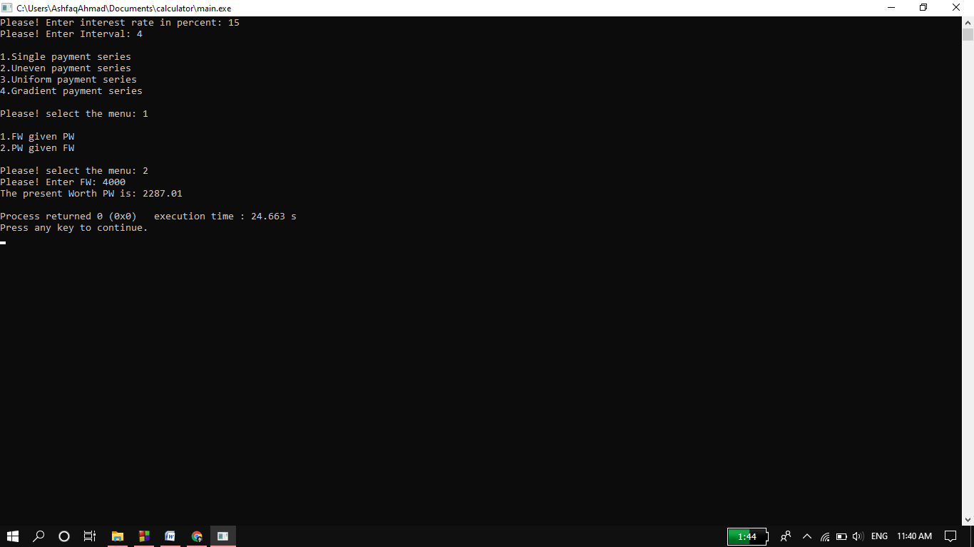

Uneven payment series

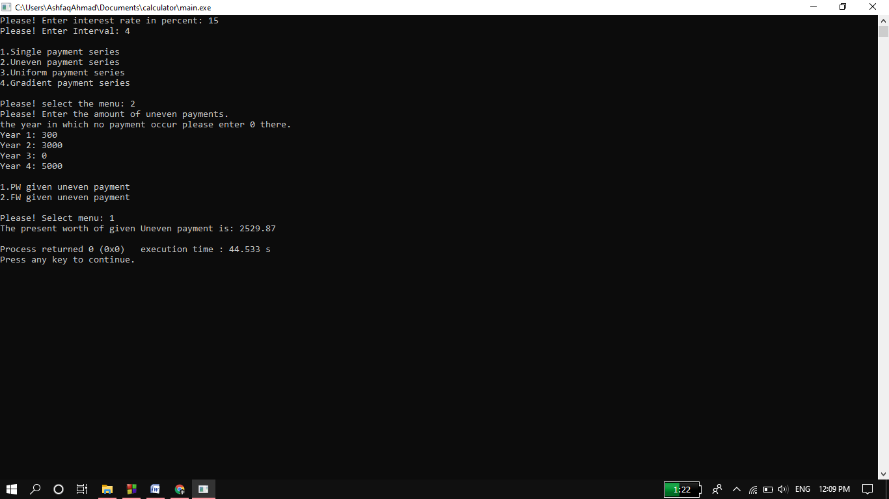

Uniform payment series

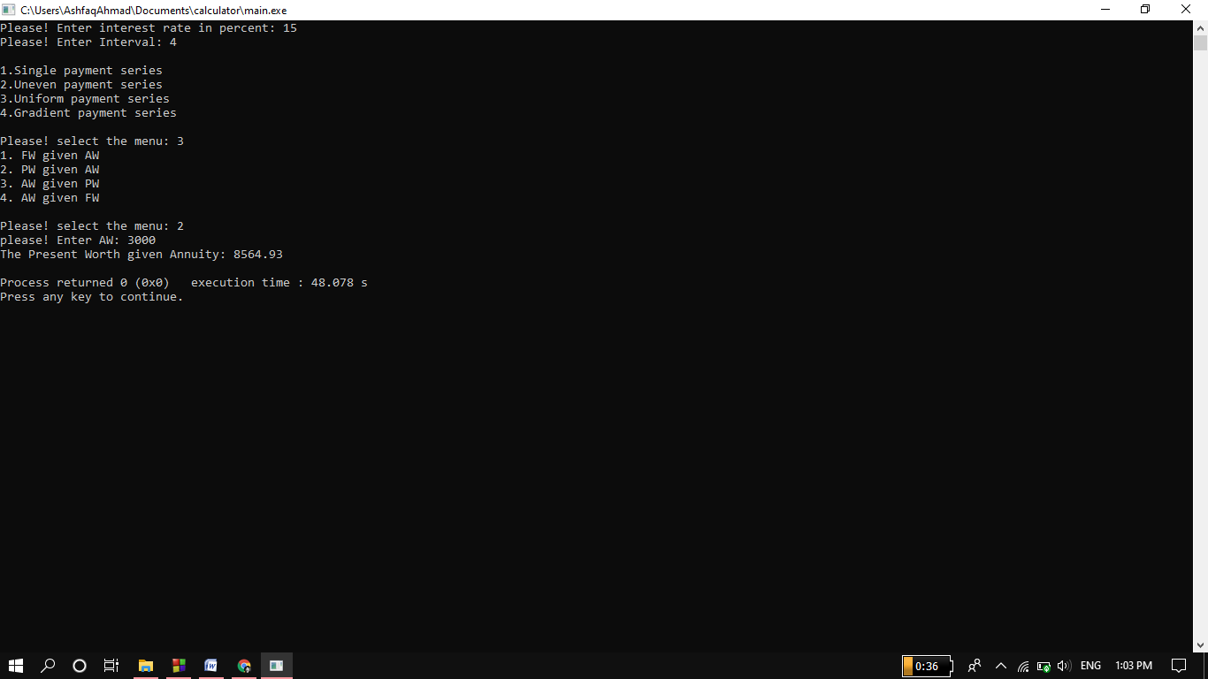

Gradient payment series:

